Mini Audio Amplifier
by
Name | ROLL NO. | Enrollment no.
RAJU KUMAR | 2002220310017 | 200222031036229
SANJEEV KUMAR | 2002220310019 | 200222031036231

A Comprehensive project report has been Submitted In partial fulfillment of
The requirement for the degree of

Bachelor of Technology
in
Electronics and Communication Engineering

Under the Supervision of

MR. SHAHID KHAN


I.T.S Engineering College, 46, Knowledge park-iii, Greater Noida, u.p. (india)
Affiliated to DR. A.P.J Abdul kalam TECHNICAL university

March 2022
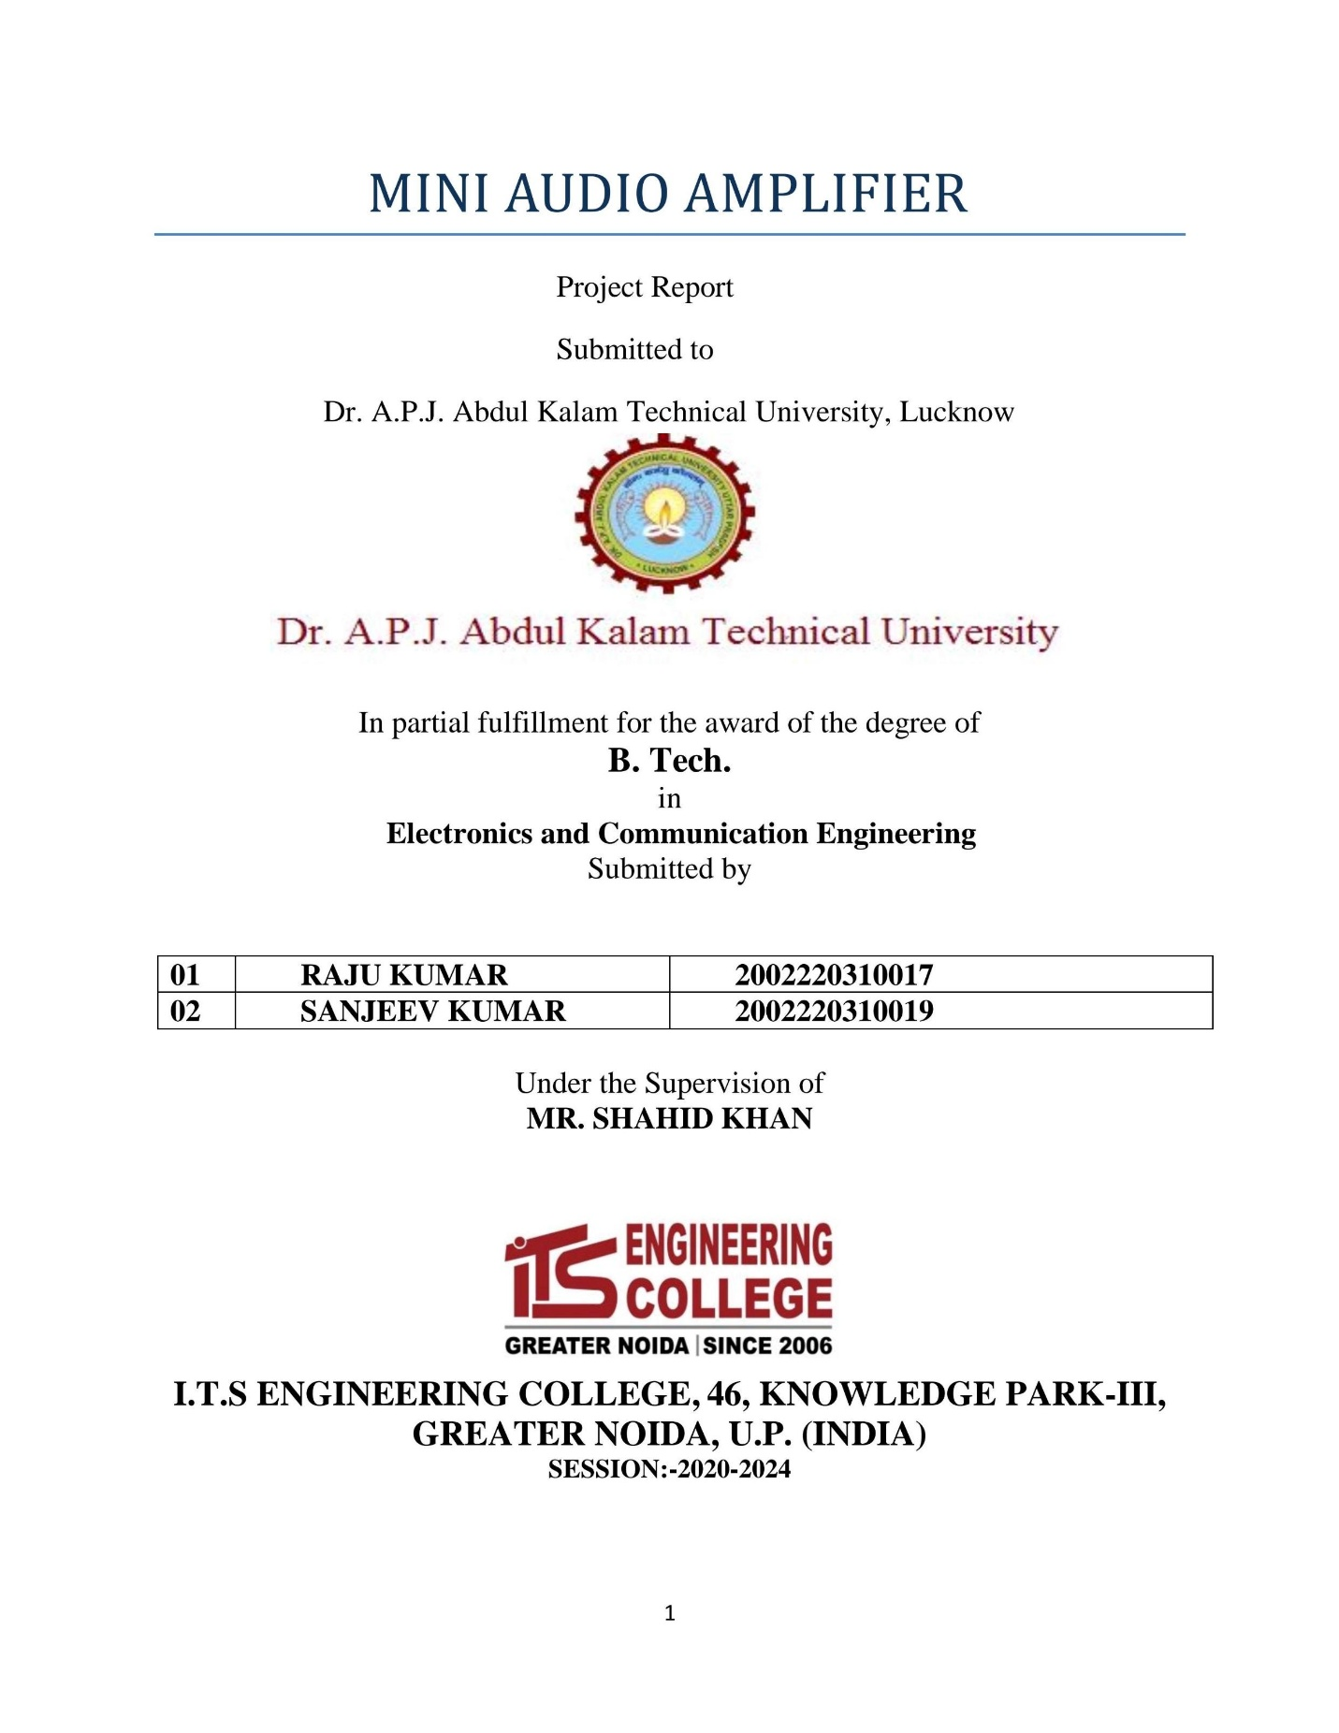

CERTIFICATE

This is to certify that RAJU KUMAR Roll no -2002220310017 and SANJEEV KUMAR Roll no -2002220310019 has carried out the project work presented in this report entitled “AUDIO AMPLIFIER” for the award of Bachelor of Technology in the stream of Electronics and Communication Engineering from Dr. A.P.J. Abdul Kalam Technical University, Lucknow under the supervision of Mr. SHAHID KHAN, Assistant Professor (ECE). The report embodies results of work, and studies are carried out by the student himself/herself and it is an authentic report.

Name of Supervisor: - HOD
Mr. Shahid Khan Dr. Monika Jain
Professor and Head – ECE

ACKNOWLEDGEMENT

We feel great pleasure to acknowledge all those involve in the process of our education and research. In the first place we would like to record our deep and sincere gratitude to our in charge, MR.SHAHID KHAN for his supervision, advice, guidance, and crucial contribution, which made him a backbone of this project.
His understanding, encouraging and personal guidance have provided a good basis for the present project. His involvement with his originality has triggered and nourished our intellectual maturity that we will benefit from, for a long time to come. We wish to express our gratitude towards our all teachers, who helped us throughout our course work. We extend our acknowledgement to our lab mates, lab staff, who are directly or indirectly involved in carrying out the project work.

CONTENTS

S.NO. TOPIC PAGE.NO.

- ACKNOWLEDGEMENT …………………………………. …(i)
2. CONTENTS …………………………………………………. (ii)
3. ABSTRACT ……………………………………………… ….(iii)
4. CHAPTER 1 Introduction …………………………………….. 1
5. CHAPTER 2 Circuit Components ……………………………. 4
6. CHAPTER 3 Circuit Diagram …….…………………………. 12
7. CHAPTER 4 Advantage and Disadvantage…......…………… 16
8. CHAPTER 5 Applications …………………………………… 17
9. CHAPTER 6 Conclusion…………… ……………………….. 18
10. REFERENCES ………………………………………………..

ABSTRACT

The aim of this project was to design and develop a mini audio amplifier. The amplifier is mainly for the CD, DVD played which are most common audio player today. In this Project, we study the audio amplifier circuits. Moreover study the flow of the whole system from weekl signal to the loudspeakers. Each functions of the components in the amplifier.
Then the whole single ended audio power amplifier is built. After finish the whole have some different test and measurement to define the performance of the amplifier.
Finally, the most important thing was use the amplifier to listen music and feels the different of transistor amplifier.

CHAPTER -1

  - Introduction
Audio amplifier is the basic circuit configuration that is required to amplify, the audio signal received through a device like a microphone or the audio signal that is to be transmitted out through a speaker/ Radio device/Wireless transmitter etc .
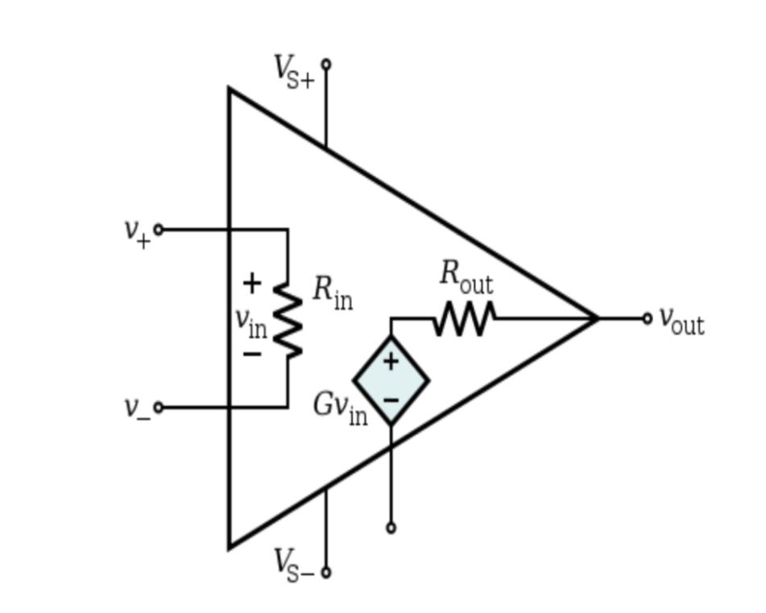
What is audio amplifier?
A basic power amplifier that is designed to take input as the low strength audio signal and generate the output signal that consists of the high strength value. This process of amplification is utilized in the various domains where an electical signal is converted to an acoustic signal. This type of amplifiers is known as audio amplifiers. Any circuit which processes the audio signal has the audio amplifier both at the input and also at the output. For example, if a microphone receives a sound wave input signal it need a pre-amplification of the signal before processing it further and similar before sending an electrical signal to a speaker it needs to be amplified.
CHAPTER – 2
2.1 CIRCUIT COMPONENTS:-
RESISTORS:-
Resistors are the most common passive electronic component (one that does notrequire power to operate). They are used to control voltages and currents. While a resistor is a very basic component, there are many ways to manufacture them. Each style has its own characteristics that make it desirable in certain types of applications. Choosing the right type of resistor is important to making high-performance or precision circuits work well. This bonus chapter covers the resistor types and helps with picking the right one for your project. All resistors are basically just a piece of conducting material with a specificvalue of resistance. For that piece of conducting material to be made
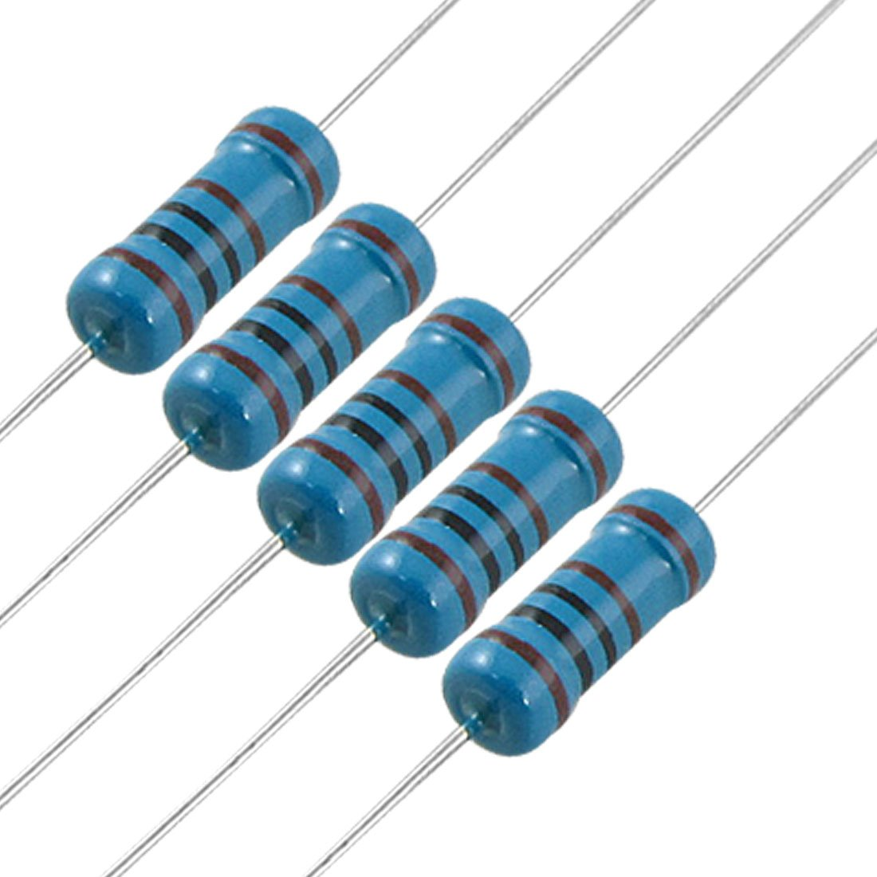
Into a practical resistor, a pair of electrodes and leads is attached so current can flow. The resistor is then coated with an insulating material to protect the conducting material from the surrounding environment and vice versa. There are several different resistor construction methods and body styles (or packages) that are designed for a certain range of applied voltage, power dissipation, or other considerations. The construction of the resistor can affect its Performance at high frequencies where it may act like a small inductor or capacitor has been added, called parasitic inductance or capacitance.

2.2 CAPACITORS:-
Capacitor has ability to store charge and release them at a later time. Capacitance is the measure of the amount of charge that a capacitor can store for a given applied voltage. The unit of capacitance is the farad (F) ormicrofarad. The capacitors used in the circuit are electrolytic-capacitor. In the circuit the electrolytic capacitor is used as a bypass capacitor. Any noise variation inthe circuit is removed by the capacitor. 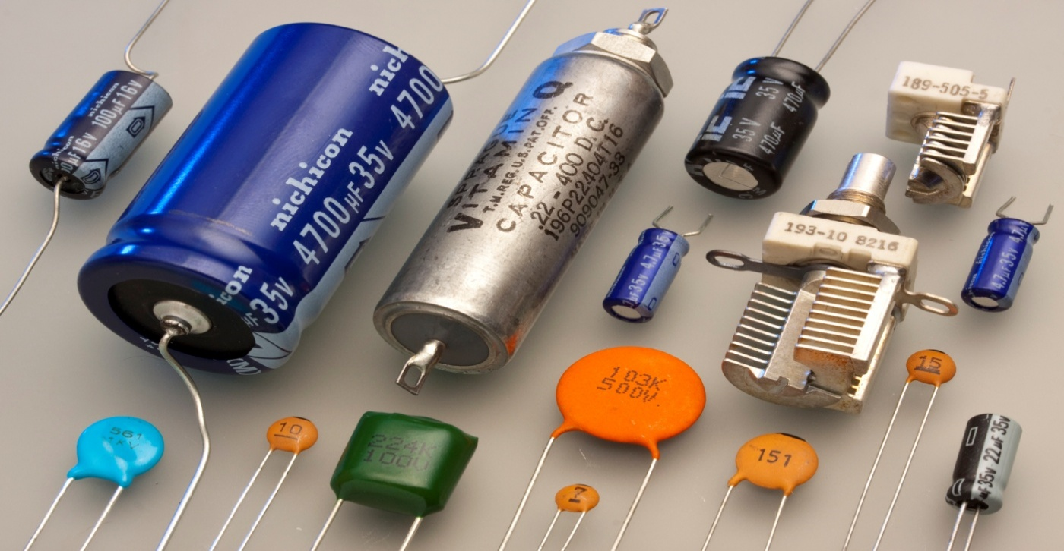

2.3 BATTERY :-
The nine-volt battery, or 9-volt battery, is a common size of battery that was introduced for early transistor radios. It has a rectangular prism shape with rounded edges and a polarized snap connector at the top The nine-volt battery format is commonly available in primary carbon-zinc and alkaline chemistry, in primary lithium iron disulfide, and in rechargeable form in nickel-cadmium, nickel-metal hydride and lithium-ion. Mercury-oxide batteries of this format, once common, have not been manufactured in many years due to their mercury content The battery has both terminals in a snap connector on one end. The smaller circular (male) terminal is positive, and the larger hexagonal or octagonal (female) terminal is the negative contact. The connectors on the battery are the same as on the load device; the smaller one connects to the larger one and vice versa.[2] The same snap-style connector is used on other battery types in the Power Pack (PP) series. Battery polarization is normally obvious; problem with this style of connector is that it is very easy to connect two batteries together in a short circuit, which quickly discharges batteries, generating heat and possibly a fire.
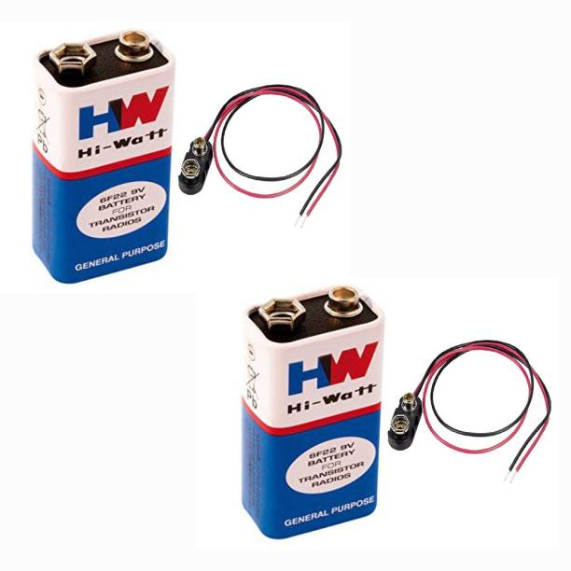

2.4 TRANSISTOR:-
A transistor is a semiconductor device used to amplify and switch electronic signals and electrical power. It is composed of semiconductor material with at least three terminals for connection to an external circuit. A voltage or current applied to one pair of the transistor's terminals changes the current flowing through another pair of terminals. Because the controlled (output) power can be higher than the controlling (input) power, a transistorcan amplify a signal. Today, some transistors are packaged individually, but many more are found embedded in integrated circuits.
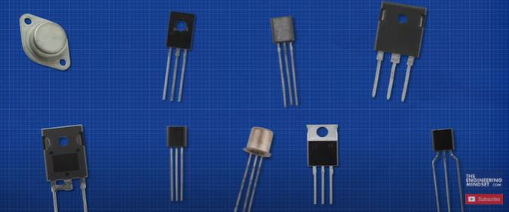

2.5 IC 358 The IC or integrated circuit is a little black chip, it is a root of modern electronics, and also an essential component in many electronic circuits
What is LM358 IC ?
LM358 IC is a good, standard operational amplifier and it is suitable for your needs. It can handle 3-32V DC supply & source up to 20mA per channel. This op-amp is apt, if you want to operate two separate op-amps for a single power supply. It's available in an 8-pin DIP package.

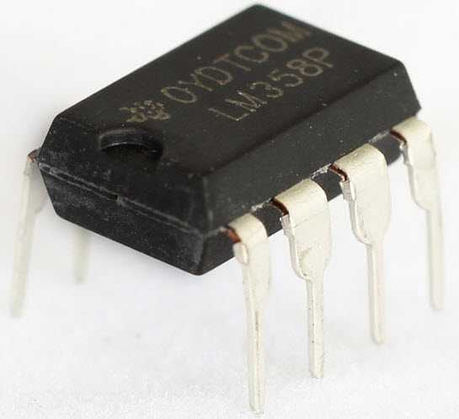

2.6 ZERO PCB BOARD:-
Zero PCB is basically a general-purpose printed circuit board (PCB), also known as perf board or DOT PCB. It is a thin rigid copper sheet with holes pre-drilled at standard intervals across a grid with 2.54mm (0.1-inch) spacing between holes. Each hole is encircled by a round or square copper pad so that component lead can be inserted into the hole and soldered around the pad without short-circuiting the nearby pads and other leads. For connecting the lead of component with another lead, solder these together or join these using a suitable conducting wire.

2.8 MICROPHONE:-
Sound energy received by microphone is converted to electrical signals. Microphones are types of transducers, they convert acoustic energy i.e. sound signal. Basically, a microphone is made up of a diaphragm, which is a thin piece of material that vibrates when it is struck by sound wave. This causes other components in the microphone to vibrate leading to variations in some electrical quantities thereby causing electrical current to be generated. The current generated in the microphone is the electrical pulse. The current generated by a microphone is very small and this current is referred to as mic level and typically measured in milli-volts. Before it is usable, the signal must be amplified, usually to line level, with typical value within (0.5 – 2) volts, which is stronger .So the signal produced by microphone is amplified by transistor Q1
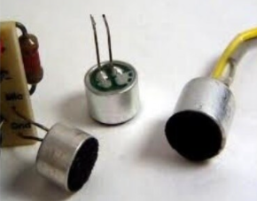
2.9 Stereo audio jack connector :-The RCA connector was introduced in the 1940s by RCA for home phonographs. It is slowly being supplanted by connections like HDMI the audio-visual realm, but the ubiquity of theconnectors and cables makes it a good candidate for home-built systems.
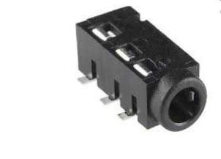

CHAPTER -3

WORKING PROCESS:-
This mini amplifier can work without any issues or errors through supply voltages between 3v to 12v using source resistances as:
The working of the amplifier is not on a single stage. This amplification of the audio signals is carried out in various stages.
The power generated at the output of these amplifiers depends upon its utility. The amplifiers can be designed with multiple transistors in it. Based on these movements of the carriers the signal reaches to its destination. This process signal reaching to the destination with the replica of the input signal but boosted in terms of strength is known as amplification.
CHAPTER -4
ABOUT THE CIRCUIT DIAGRAM:-
APPARATUS REQUIRED:-

(1.) Transistor –BC547
(2.) Microphone -1
(3.) Capacitor – 3( 0.1microfarad.) i.e 104
(4.) Resistor – 1(1m ohm)
(5.) Resistor – 560 ohm
(6.) Resistor – 5(10kilo ohm) , 2(100kilo ohm)
(7.) Batter- 09 volt.
(8.) Zener diode- 5.0 V
(9.) IC - LM358P
(10.) General purpose PCB
(11) Stereo Audio jack
Connect all components according to this circuit diagram

CHAPTER-5

CIRCUIT DIAGRAM

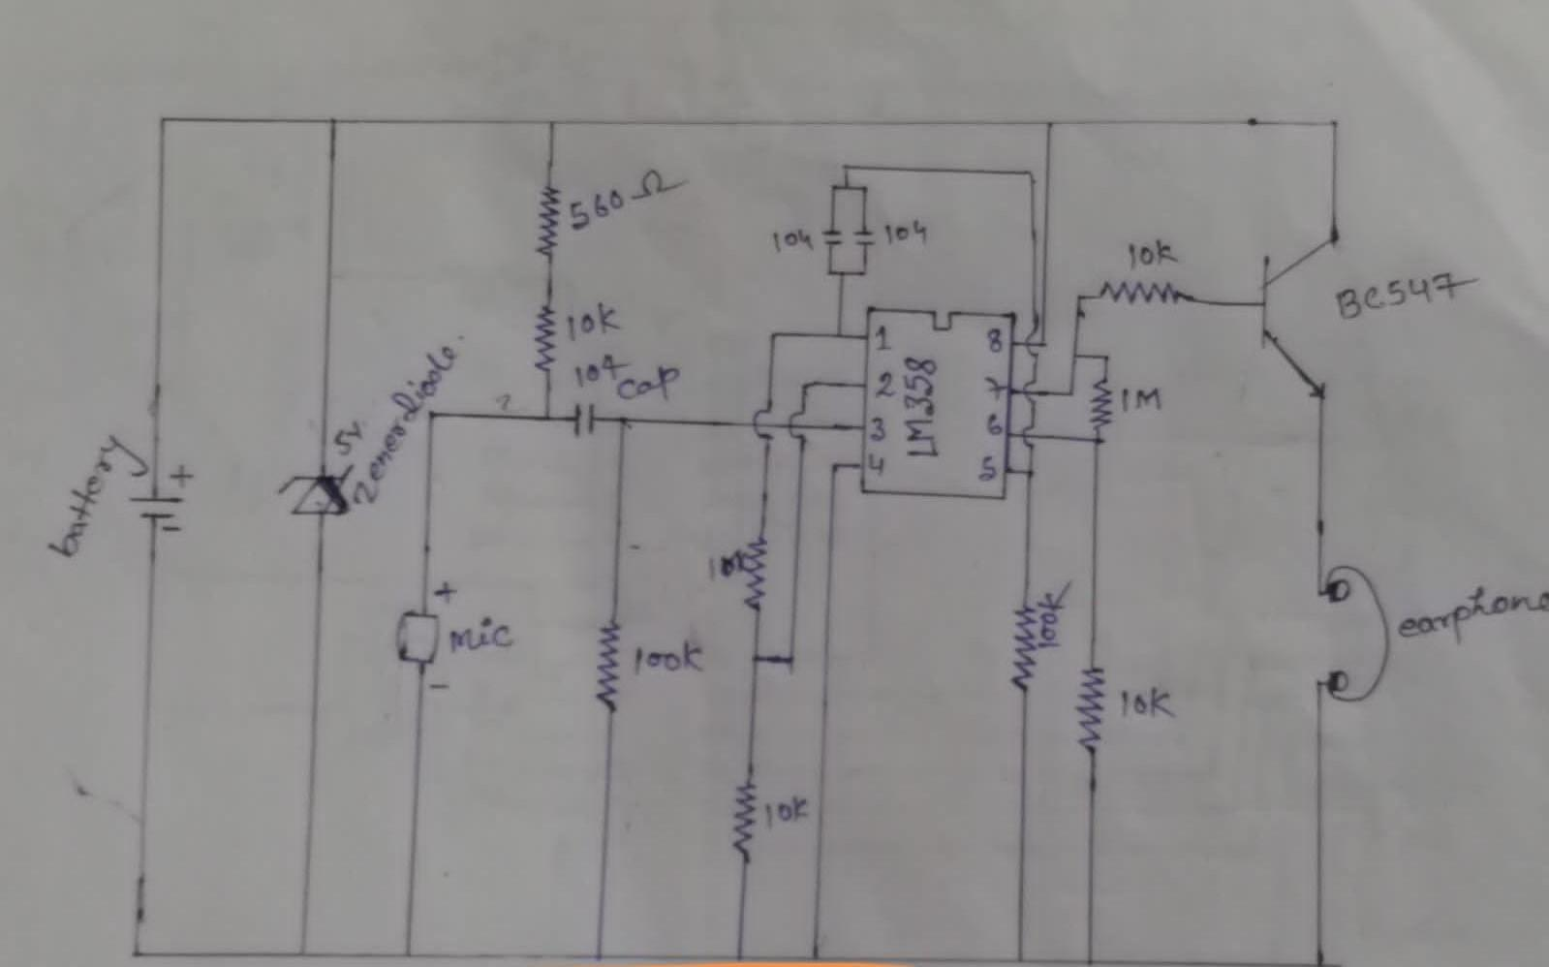
CHAPTER-6
ADVANTAGES :-
- A common emitter amplifier is inverting and has low input impedance
- high output impedance
- high voltage gain
- high current gain

CHAPTER -7
DISADVANTAGES :-

- It has a high output resistance.
- It responds poorly to high frequencies.
- It has high thermal instabilities.
- It's voltage gain is very unstable.

CHAPTER-8
APPLICATION:-
- In the sound systems, these amplifiers are most widely used.
- In various instruments that relate to music, these amplifiers are installed.
- In the radio signals broadcasting these amplifiers are used.
- The signal transmission for long-distance communication is the most amplifiers that are utilized.
- For the wireless transmission of the signals, audio amplification is required

CHAPTER-9
CONCLUSION
mini audio amplifier circuit suitable for small pocket radios and other portable audio gadgets. used to amplify weak audio signals from an input like a mic to high amplitude signals

CHAPTER-10
REFERENCES

1. Bruce Rozenblit (1997), BeginnerȂs Guide to Audio Design
2. http://www.diyzone.net/
3. http://en.wikipedia.org/wiki/Main_Page
4. www.electronicshub.org
5. High-Power audio amplifier Construction Manual by G.Randy Slone
6. Designing Audio Power Amplifier by Bob Cordell
7. www.researchgate.net
8. Audio Power Amplifier Design Handbook

